

Array Based Programs (1-25)

Date – 14/03/2026

Name: M. Sahasra
Reg. No.: 192425317
Course Code: CSA0919
Course Name: Programming in Java for Spring Framework
Faculty Name: Dr. Magesh Kumar

1. Find Maximum and Minimum in Array

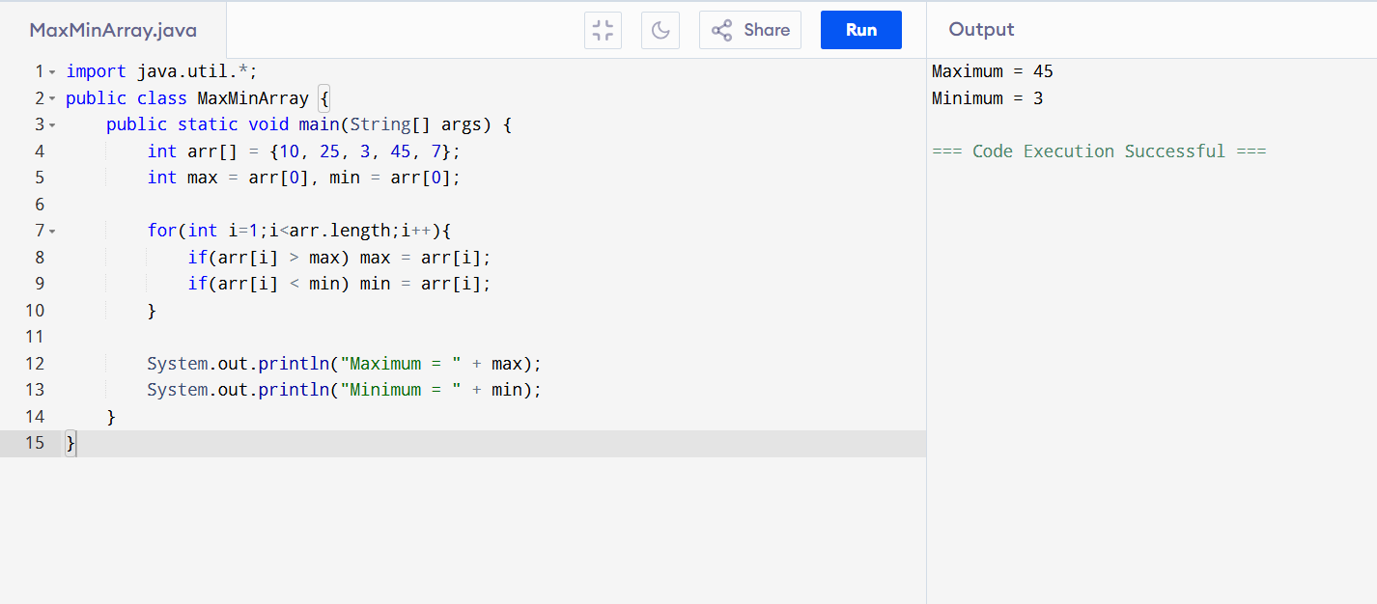
2. Reverse an Array
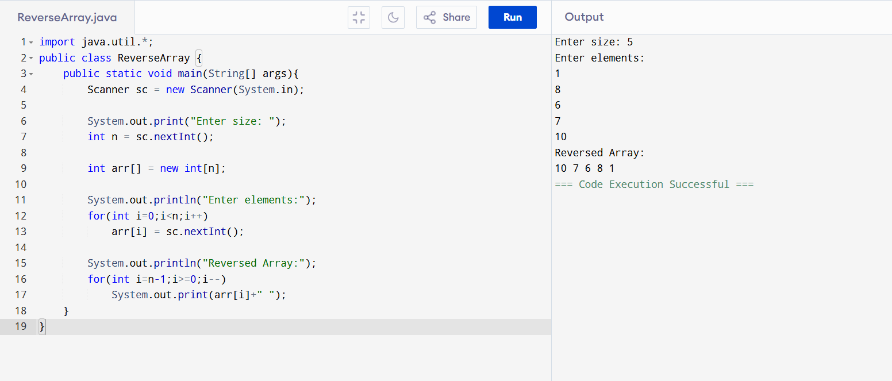

3. Sort Array in Ascending Order
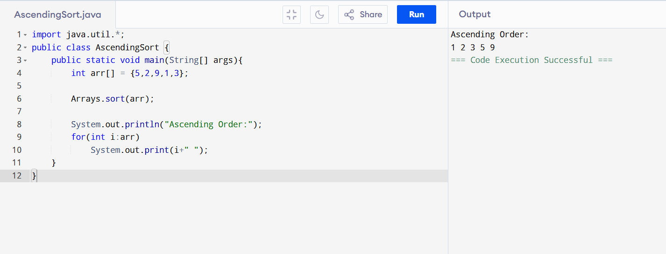

4. Sort Array in Descending Order
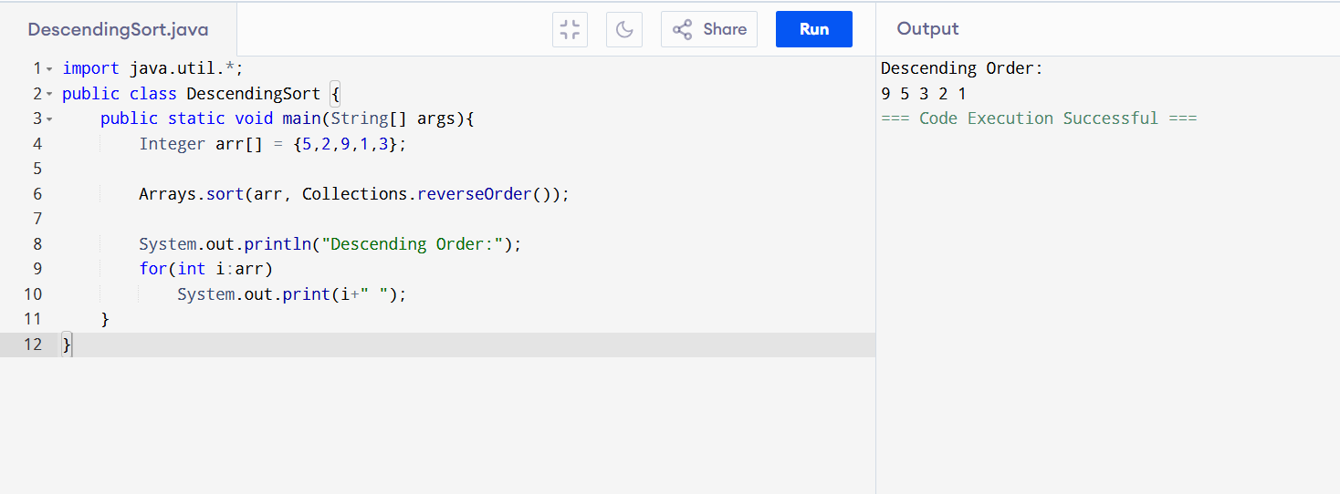
5. Addition of Two Matrices
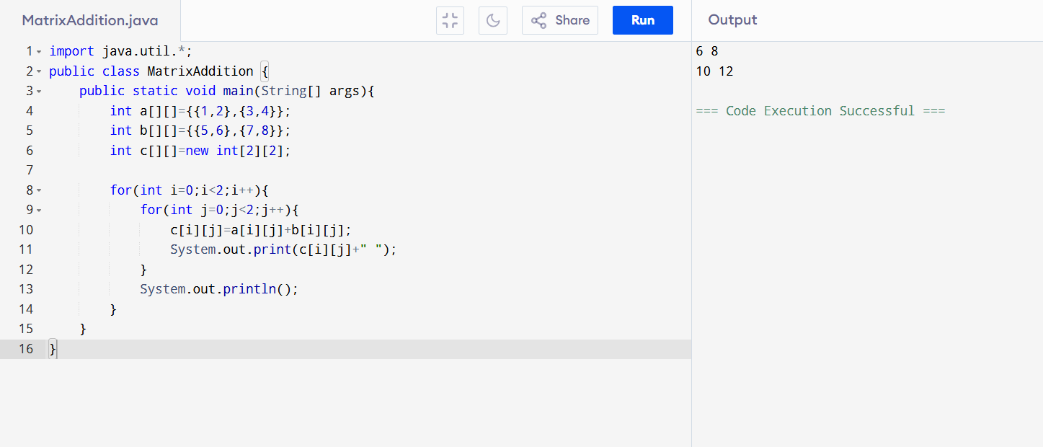

6. Find Duplicate Elements
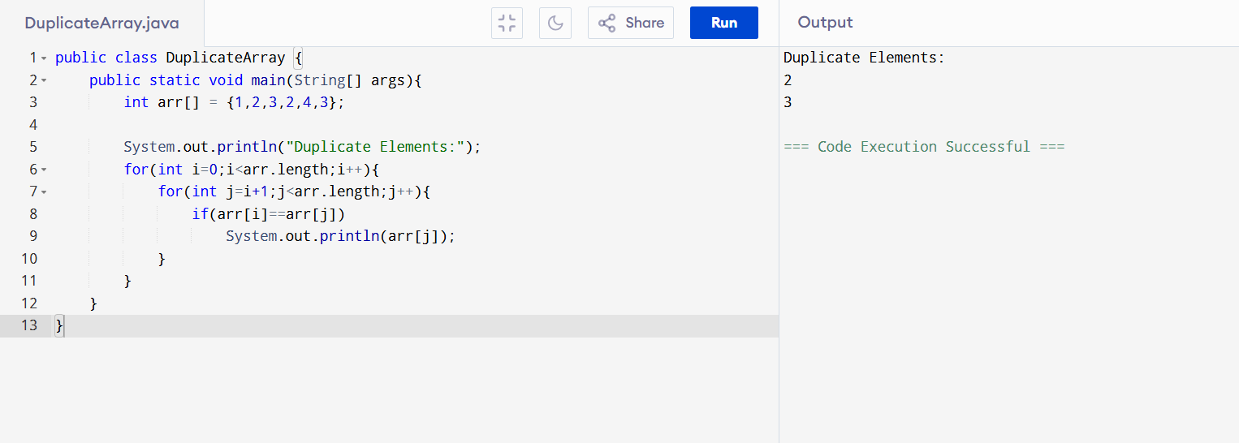

7. Sum of Array Elements
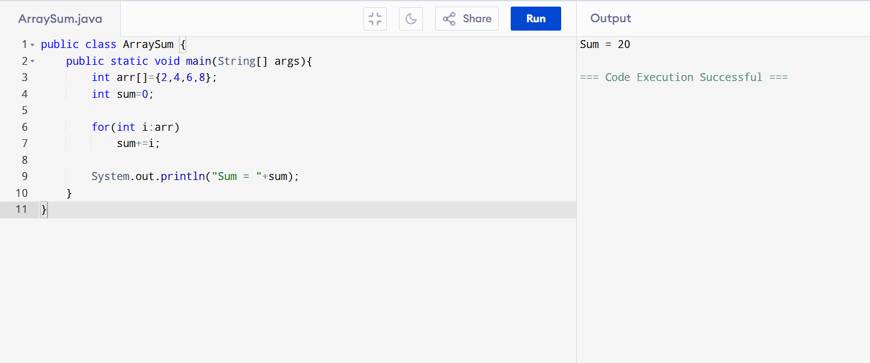
8. Count Even and Odd Elements
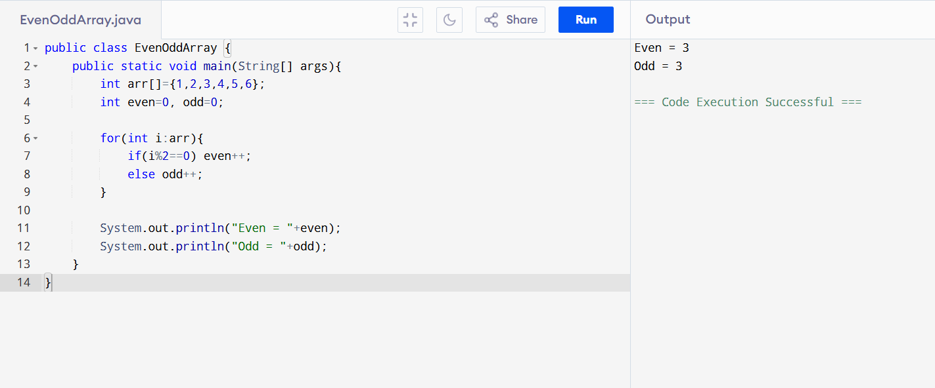

9. Insert Element at Specific Position
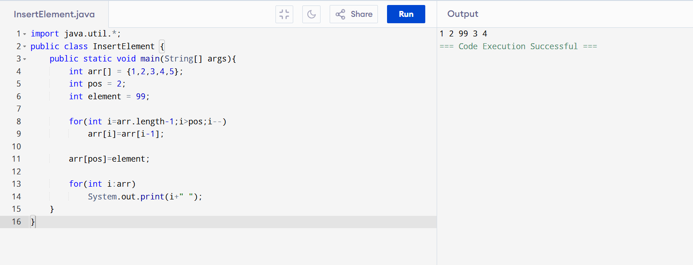

10. Average of Array Elements
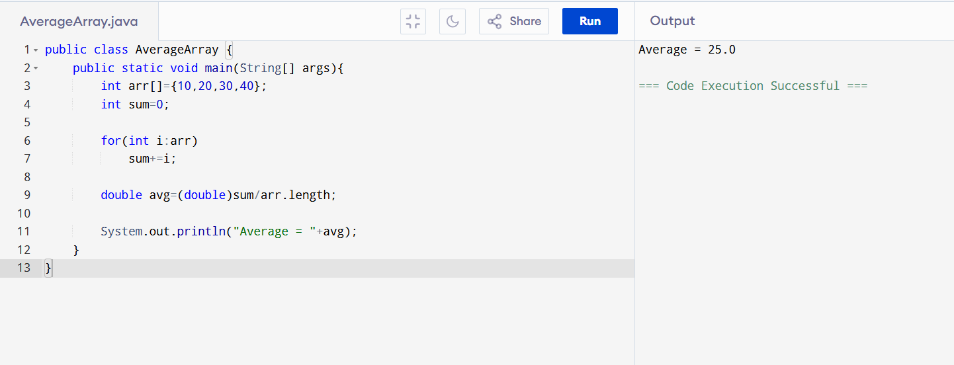
11. Multiply Two Matrices
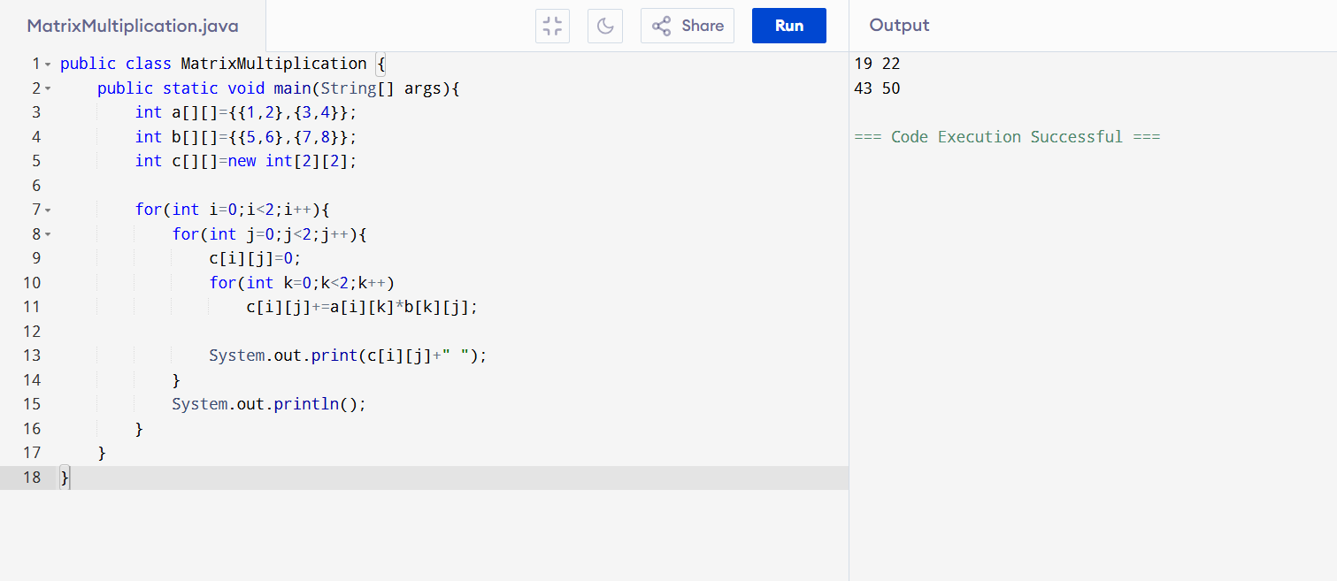

12. Transpose of Matrix
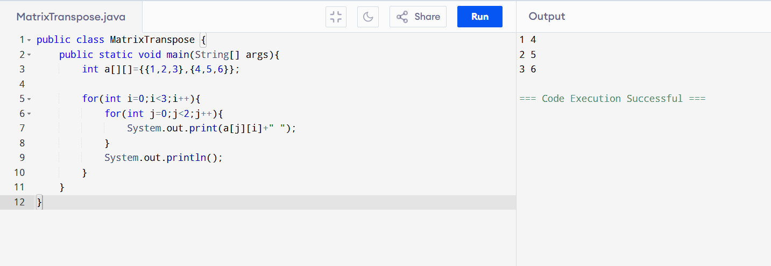
13. Union of Two Sorted Arrays
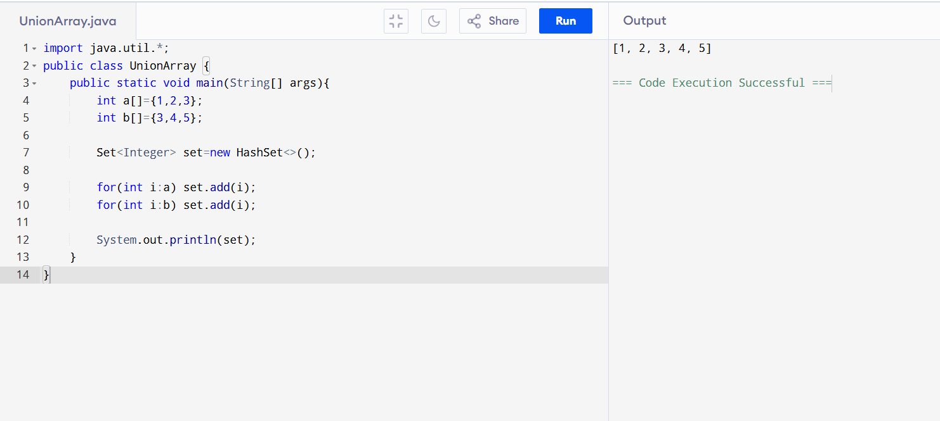
14. Largest and Smallest Element in Matrix
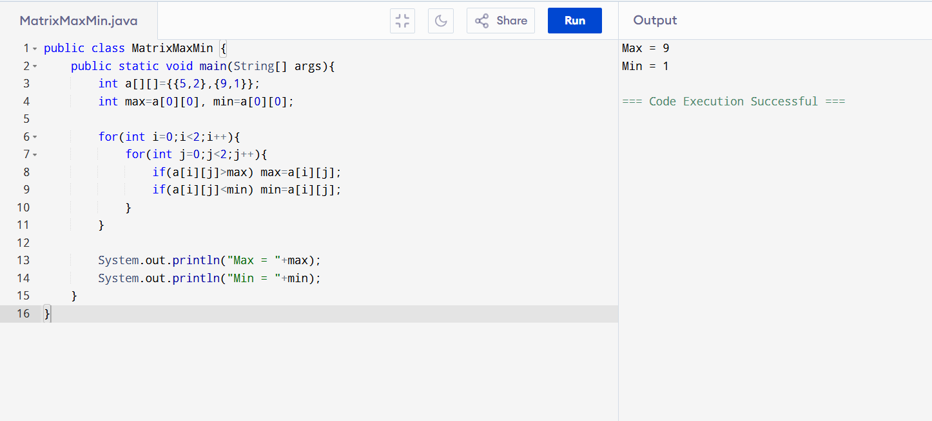

15. Binary Search
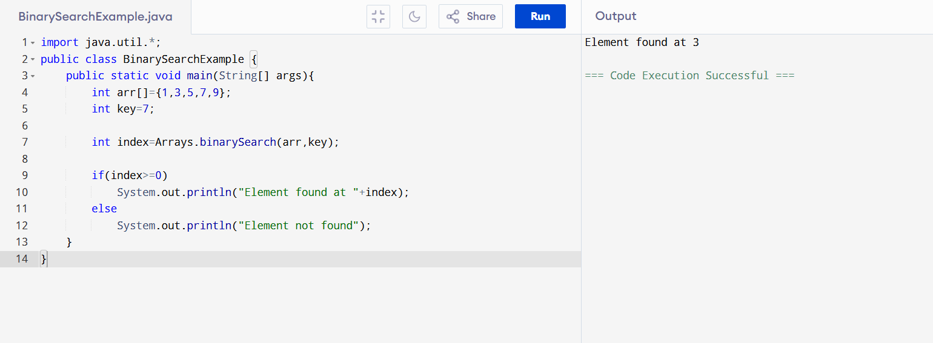

16. Linear Search
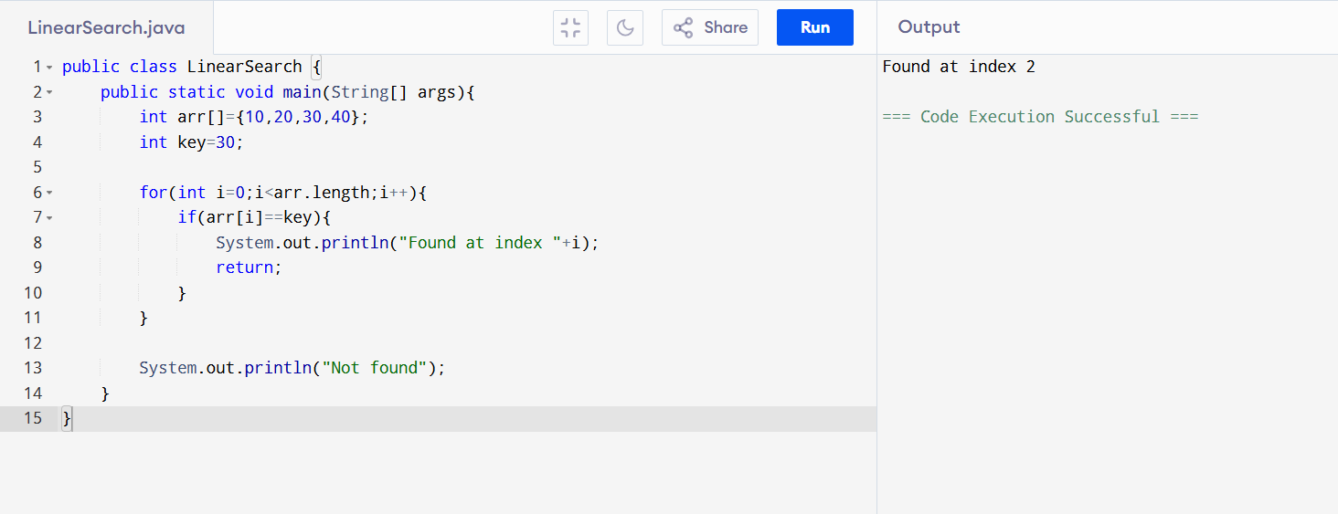
17. Sum of Diagonals of Matrix
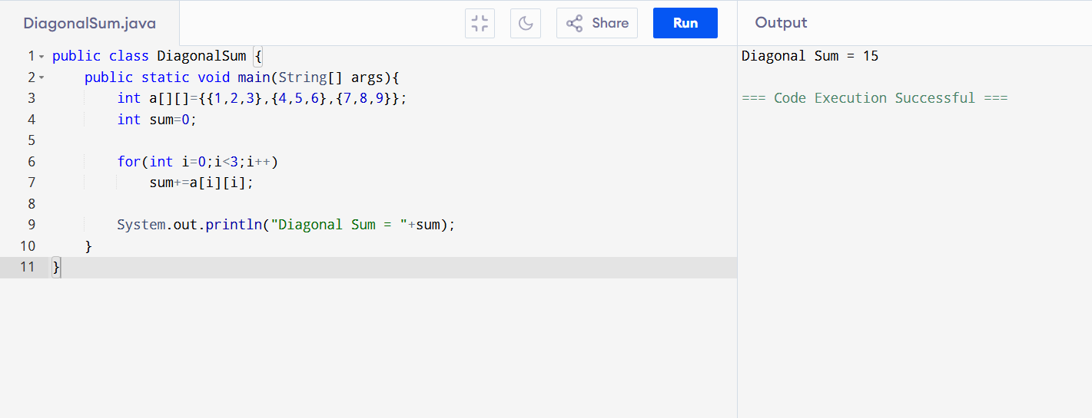

18. Majority Element (> n/2)
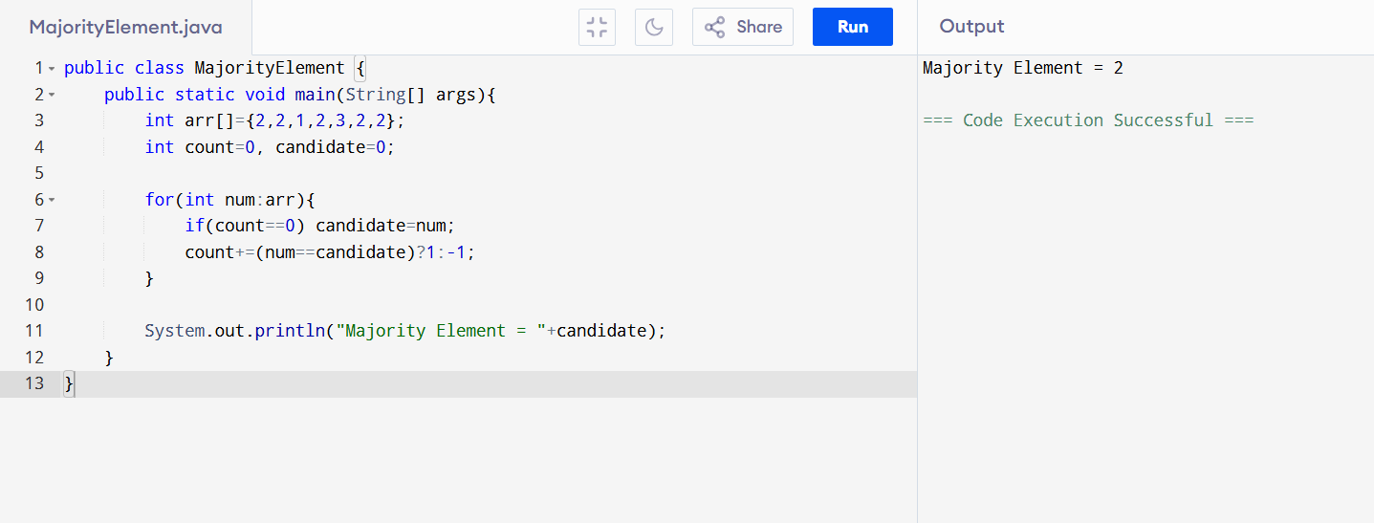

19. Maximum Product Subarray
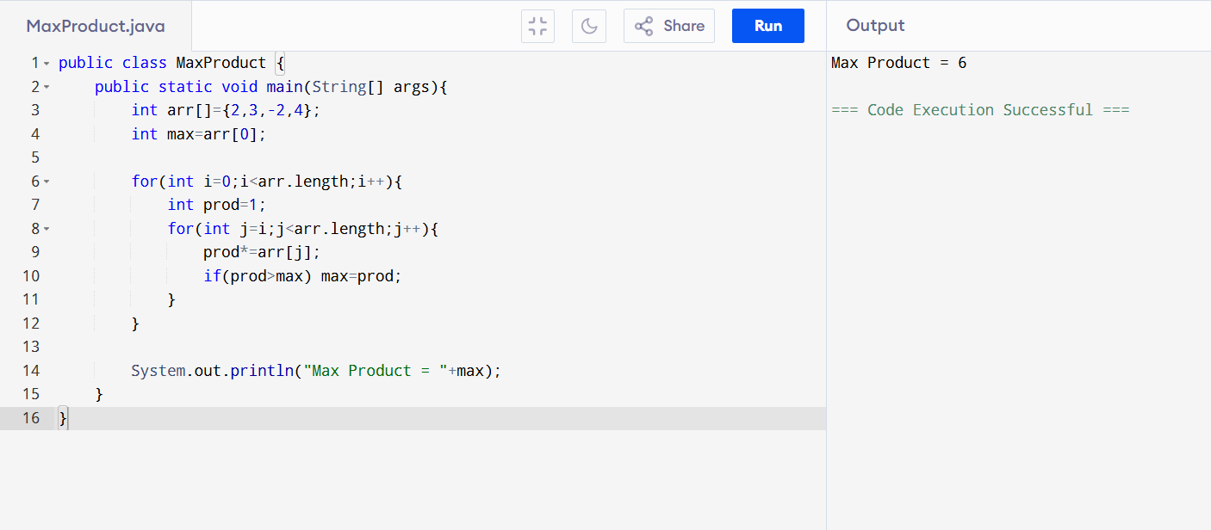
20. Common Elements Between Two Arrays
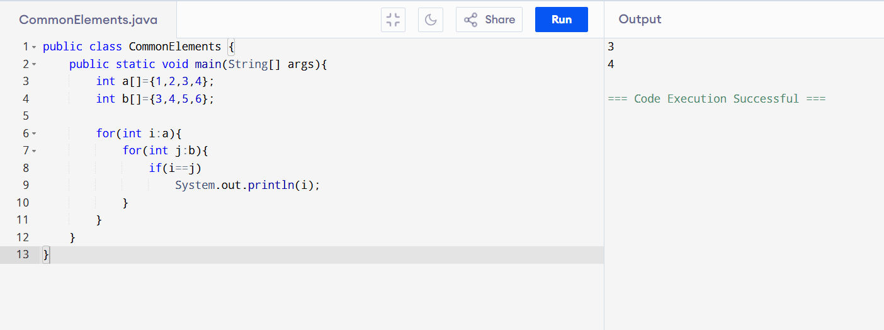

21. Intersection of Two Arrays
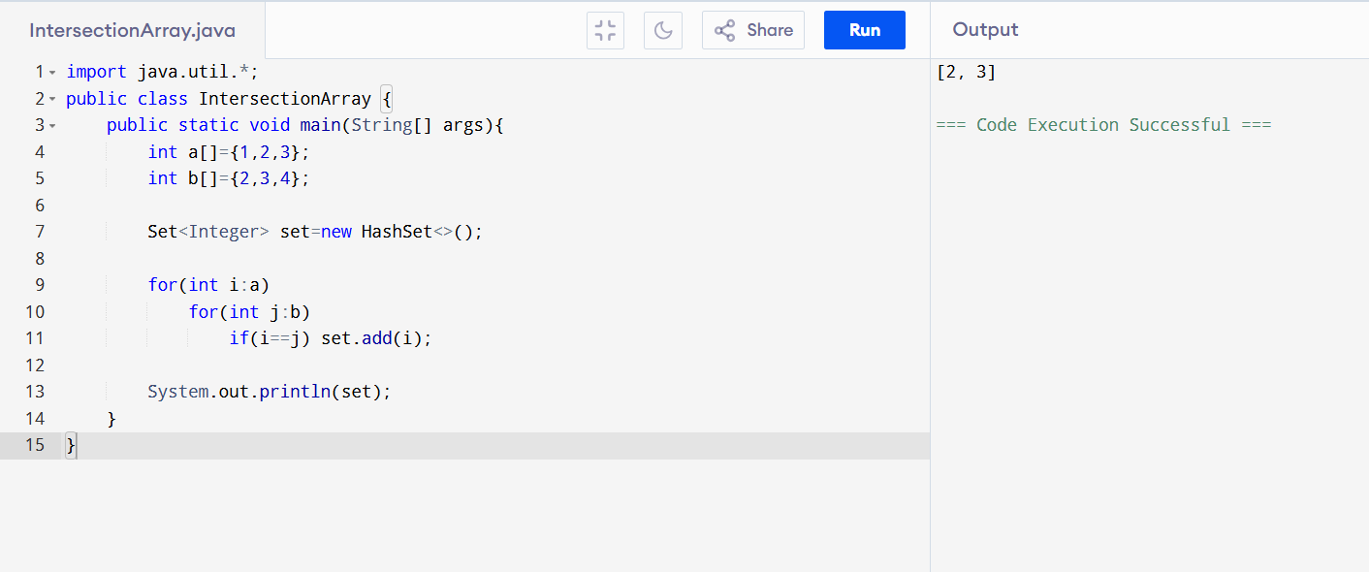

22. Rotate Array Right by K Positions
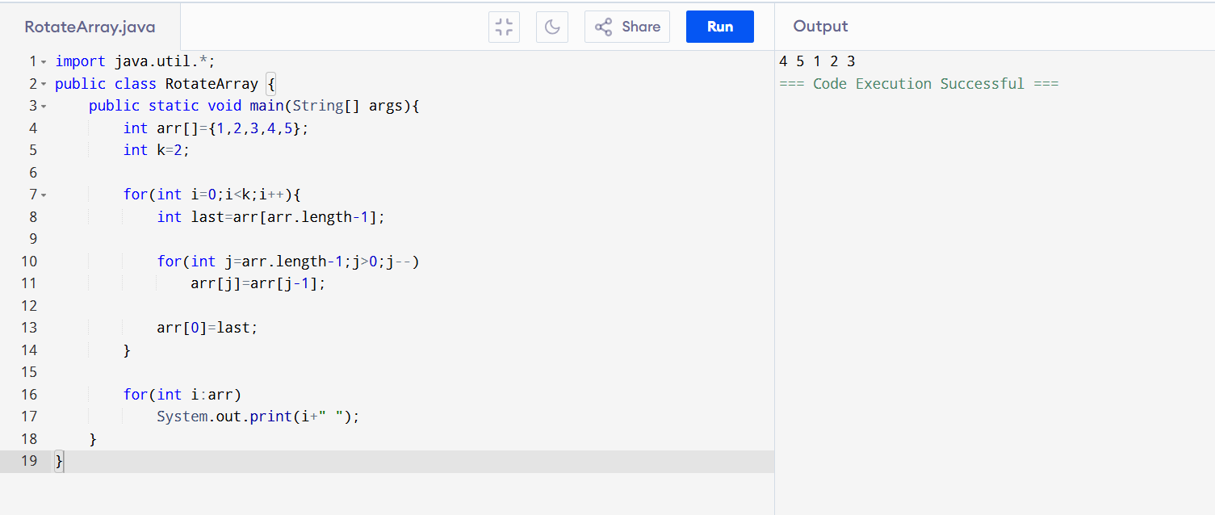
23. Maximum Difference Between Two Elements
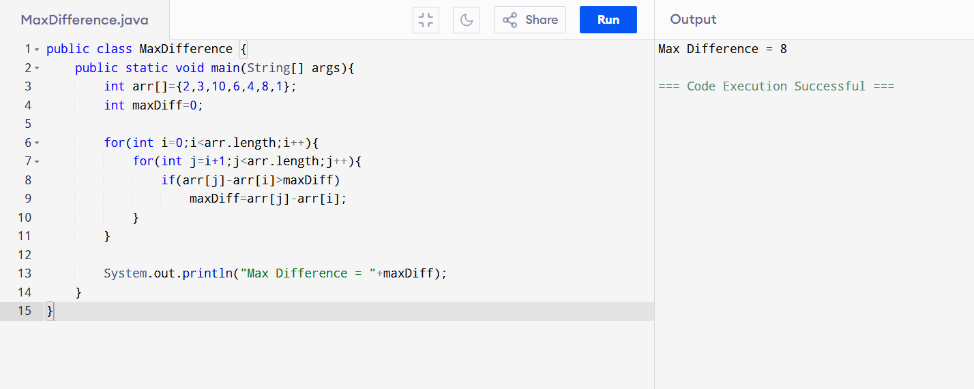

24. Even Elements Before Odd Elements
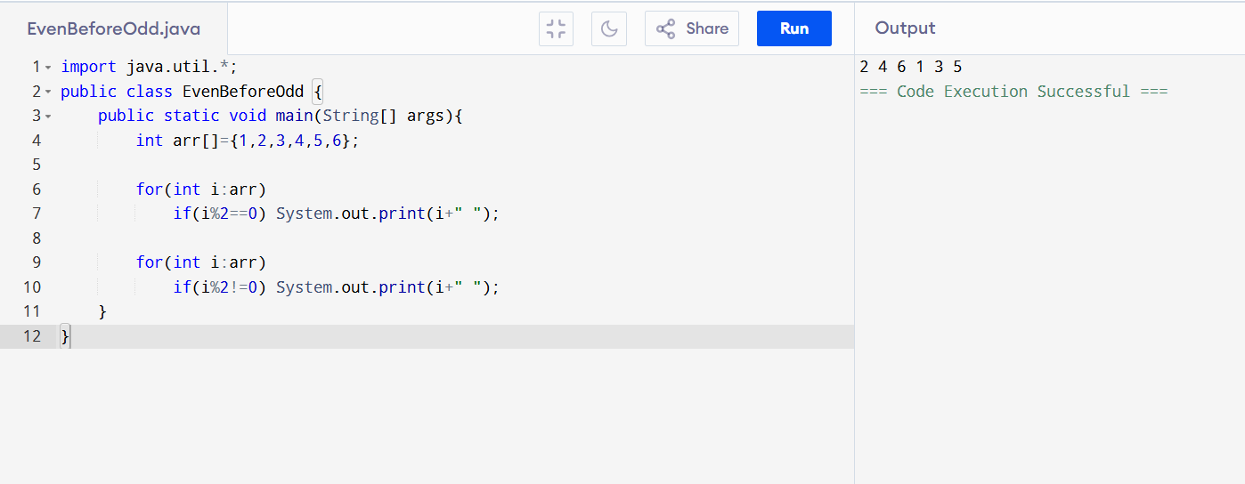

25. Negative Elements Before Positive Elements
